Creating personas Guide
Use this personas template a guide. The steps to take can look different for each company but this is a good framework to find a structure that works for you and your company.

STate Your Goal
Though personas don’t have to be all about your company, it’s important to think what you hope to get out of making personas. Do you want to provide more engaging content? Enter a new market? Increase sales? Increase inquiries? Improve customer retention? Improve the customer service or acquisition process? Also, consider what success looks like.
Example: We want to improve customer retention by 20% within 6 months of persona implementation.

Identify stake holders
Think about the people that touch customers/clients regularly. Everyone in the sales funnel (including those in retention) should have a say in persona making, as well as at least one person that would be able to garner company wide buy-in (likely someone in the C-suite). Also, consider including at least one person that may be somewhat skeptical of the process so they can be devil’s advocate. (See: Getting Buy-In for tips)
Department/Team | Name(s)
Marketing Team:
Customer Service:
Social Media:
Sales Team:
Executive (or someone with high influence/authority):
Other (someone who’s made personas at a previous job, devil’s advocate, etc.):

Beginner Level
These are the steps to make proto-personas, also known as skeleton personas. These personas are created with minimal research & data but can start a good conversation and a framework for your company to build upon.

Brainstorm Customer/Client problems
Each person take 5-20 minutes to write down any goals, problems or needs your customers may have based on your experiences. This doesn’t have to relate just to your industry or product, but rather, what these people experience on a day to day. Seemingly unrelated items could be motivations.
Examples:
- Needs reliable transportation for kids.
- Needs a way to share files with multiple employees
- Wants to lose 20 pounds.
- Having trouble paying back student loans.
- Wants to buy a house by 35.
- Can’t remember all their login information.

Find Commonality with problems
Reconvene and write down everyone’s problems on a white board, post it notes, shared Google doc, etc. Make sure you can see them (take a photo if you do it on something non-electronic. Look for overlap (this shows consensus), and look for commonalities. Group those commonalities together & write down those groups.
Examples:
- People looking to improve their physical appearance.
- People that want to get their finances in order.
- Company struggling to transition to more employees.

Write Down Attributes
Each person, take 5-20 minutes to write down attributes that would be associated to each problem group. Reconvene and write down the attributes. Together, decide what stays.
Examples:
- People looking to improve their physical appearance.
  - Someone that made their New Year’s resolution to go to the gym for often
  - A bride that wants to improve her complexion for the wedding
- People that want to get their finances in order.
  - A 33 year old that had disposable income now that his student loans are paid off.
  - Recent college graduate surprised by loan payment and wants to start a budget.
  - A family with a new baby that wants to put money away for college
  - Recent divorcee picking up the pieces.
- Company struggling to transition to more employees.
  - A consultant that wants a partner to start an agency
  - A 5 person company with a big new client that needs to hire rapidly

Gather Data to Verify
Spend 15-30 minutes identifying data that backs up the assumptions. This data can be in your CRM, sales, analytics, studies on the industry, etc. Disregard anything not data-bound.
Example:
- People that want to get their finances in order:
  - 20% of people that call and can’t pay their car payment mention student loans as a top reason.
- People looking to improve their physical appearance:
  - There is a 40% surge in gym memberships between December & February.
- Company struggling to transition to more employees.
  - 75% of companies that double their number of users up their membership level within 6 months.
Proto-persona steps complete. Proceed to “Create the Persona” unless you intend to do additional research…

Intermediate Level
This is the level many companies tend to stop at—a lot of research but not speaking with the customer. This will get you to the point where when you’re ready to speak with your customer you have a good understanding of what questions to ask to really solve their pain points and understand the industry landscape.

look at yourself
Look at all pages on your website, your blog, your social media, press, blogs, interviews, reviews & forums, pull out key words, phrases & hashtags. Google your company, read any press and write down key words and phrases on the first 3-5 pages in results. Look at email campaigns, customer service emails, phone logs for key words & phrases. Also, write down your most popular web pages & sale items. (Don’t limit yourself to the space her if you think more words are necessary, I usually have up to 25 in each section.)

Write Down Keywords, Phrases & Hashtags:

Website/Blog | Social Media | Press & Interviews

Forums/Reviews | Customer Service | Email Campaigns

Top Webpages:

Top Sale Items:

Look at your industry & Identify Competitors
Do research on market size (https://www.owler.com), key influencers, top competitors (http://www.spyfu.com), display ads (https://moat.com), search ads (https://www.ispionage.com). Find out key associations, LinkedIn & Meetup groups, top referral site (https://www.similarweb.com). Facebook/Twitter Audience Insights & Google Display Planner. Try Google Searches like “How to choose…” to see what guides exist. (All links are free or freemium, see more tools, including paid, in the references section.)
Key Players/Thought Leaders: | Top Competitors: | Associations/Groups:

Influential Social Media Accounts | Top Referring Sites/Blogs/Press: | Keywords About Competitors:

Additional Notes:
Examples:
Industry Market Size, Keyword Searches, Important Conferences, Trade Journals, links to places where you found information, etc.

Identify Problems
Look at Reddit, forums, Quora, comments & reviews to identify problems people are having in conversation about the industry and your product. Remember: People want to make their lives better, so what they do and care about is important!
- Create a Twitter list of your best (or all) customers and see what they say when they’re not talking about your product.
- Join industry related LinkedIn Groups to see what is being posted.
- Look at forums to identify what problems people are having (and check the off-topic sections for what else they care about)
- Look at conference schedules to see what people are looking to learn in your industry.
Questions/Problems (industry) | Positive Statements (Industry) | Negative Statements (Industry)

Questions/Problems (You) | Positive Statements (You) | Negative Statements (You)

Additional Notes:
Examples:
Off-topic chatter, consistencies/inconsistencies across demographics, trends over time, links to places where you found information, etc.

Identify Customers
Start to get a better picture of who the customers of the industry are (and who your customers are).
- If you have a large email base, upload that list into Facebook & Twitter insights to see a breakdown.
- If you have an app or logged in area, you have a wealth of information about customers.
- Look at your Google Analytics demographics.
- Look up customers on LinkedIn and take note of trends in demographic information.
- Look at demographic insights: Acxiom, Neilsen’s Prizm, Experian’s Mosaic. See if you can group your personas into their segment. Consistency amongst them is good. (See resources section for links)
Top Customers/Clients by Sales | Top Customers/Clients by Social Media Interaction

Internal Demographic Notes (CRM, Google Analytics, Sales, App, etc.):
- Top ages/gender based on page visits, sales, conversions
- Top demographic interests & topics
- Organic & paid search information

Demographic Segmentation Data:
Axiom, Prizm & Mosaic segments that your personas likely fall into & quick notes about each.

Facebook, Twitter & LinkedIn Insights:
Garner insights about other pages they like, their demographic breakdown, their market segmentations. If your list or page is too small look at close larger competitors.

Reevalute personas & Confirm with Data
Take all the new information collected to make changes and updates to your previously created groupings. Identify internal or research-baked data, again, that affirms the new information for personas. This data can be in your CRM, sales, analytics, studies on the industry, etc. Disregard anything not data-bound.
Example:
- People that want to get their finances in order:
  - 20% of people that call and can’t pay their car payment mention student loans as a top reason.
- People looking to improve their physical appearance:
  - There is a 40% surge in gym memberships between December & February.
- Company struggling to transition to more employees.
  - 75% of companies that double their number of users up their membership level within 6 months.
Intermediate steps complete. proceed to “Create the Persona” unless you intend to do Qualitative Research…

Advanced Level
The most accurate information you’ll get will likely be from the first-person perspective. Many companies don’t have the resources or time to get to this level in their persona making. Thankfully, personas can continuously evolve so you can build up to this point.
At this advanced level you will likely have less personas uncertainty & can make better assumptions and decisions for your business. Use these tactics to gather meaningful details about your customers, what keeps them up at night, what gets them out of bed in the morning, what they’re passionate about.

Focus Groups
Conduct focus groups or user experience research.
Tips:
- What people say isn’t necessarily what they do.
- Be careful of your facilitator leading the question.
- Watch out for one opinion dominating the group.
- Think about incentives and how that can skew attendees.
In-Depth Guide: https://www.b2binternational.com/publications/market-research-focus-group/

Interviews
Conduct one-on-one interviews over the phone, in-person or online. You may also considering interviewing employees and prominent members of your industry to get different perspectives. (See reference section for questions).
Tips:
- Use incentives for those you don’t already have a relationship with.
- Be clear, up front that it isn’t a sales call.
- Make it easy to say yes with flexible times, calendar invites, etc.
- "The rule of thumb is, when you start accurately predicting what your interviewee is going to say, it's probably time to stop." (Source)
In-Depth Guide: http://www.slideshare.net/ZacharyCohn/18-customer-interview-tips

Surveys
Have current, past & potential customers fill out an online survey.
Tips:
- Involve people in different stages of the funnel, good & “bad” customers, and different persona groups.
- If you use a CRM system, have progressive questioning that builds on previous data.
- Gather insight from those that aren’t familiar with your product.
- If it make sense consider using quizzes as surveys & lead generation.

Where to Get Participants:
- Amazon’s Mechanical Turk – http://mturk.com
- Survey Monkey Audiences - https://www.surveymonkey.com/mp/audience/
- Survio (international & Domestic) - http://www.survio.com/en/buy-survey-responses
- Google Consumer Services - https://www.google.com/insights/consumersurveys/how
- User Testing - http://www.usertesting.com/
- Exit surveys & popups - https://qualaroo.com/

In-Depth Guide: https://www.surveymonkey.com/mp/survey-guidelines/

Create the persona

Assess your brand perception
Before you build your persona, now is the time to start thinking about your brand perception. After you've looked at all this info, think about where your company falls within the industry, before you start to build your personas. This is important to know who are you actual personas rather than aspirational (or even negative).
Example: We’re a mortgage lender. We found 4 prominent blogs that have our company in the “excellent credit score” section of lender reviews because we have such low interest rates, and we are fairly selective. Though looking at our actual customer data, all of our customer credit scores are not excellent, we do have people perceive us as a lender for only people with very good credit scores. Though we’d like to expand our market, at this time, It'd be unlikely that someone with a 650 credit would be a viable persona, but could potentially be an aspirational one.

Basic Demographic Data
This information includes age, location, job, education, etc. Things you’d likely find on someone’s resume.
Find this information: In your notes for “Write Down Attributes” (Beginner), “Identifying Customers” (Intermediate), and in information collected in interviewing & surveys (Advanced).

Family
Depending on your product, this could be a very important area. This could be anything from just marital status to a short family tree (kids, their ages, parents, their ages, etc.).
Find this information: In your notes for “Write Down Attributes” (Beginner), “Identifying Customers” (Intermediate), and in information collected in interviewing & surveys (Advanced).

Loves, Hates & Brands
These are generally broad like, “Flys Southwest”, “Shops at Whole Foods”, “Hates Social Media”. This area helps shape what your personas goals & pain points are because how people choose to spend their money & time (or not to) helps paint a picture of what they value.
Find this information: In your notes for “Write Down Attributes” (Beginner), “Identifying Customers” (Intermediate), and in information collected in interviewing & surveys (Advanced).

Goals
This is where you start thinking about what makes someone get out of bed in the morning, what makes them feel loved, wanted, validated, successful, excited, etc. This is where is it is most effective to have done customer interviews to really get a feel for this type of information, but there are still ways to get know this information. If your previous notes fall short, take a bit more time to look at individual customers, LinkedIn pages, personal websites/portfolio, Reddit profiles, etc. This will give you a more intimate look at the individual. Also, think more broadly, for instance, someone that is an Assistant Director, likely has aspirations to be a Director in the future.
Find this information: In your notes for “Write Down Attributes” (Beginner), “Identifying Customers” (Intermediate), and in information collected in interviewing & surveys (Advanced).

Pain Points
Usually pain points are what is impeding someone from accomplishing their goals. For example, if a goal is to lose 30 pounds, a pain point is likely a reason why they can’t exercise more or eat healthier. Now, think about what keeps them up at night, what makes them scared, anxious, uncomfortable, etc.
Find this information: In your notes for "Brainstorm Customer/Client Problems" (Beginner), "Identify Problems" (Intermediate), and in information collected in interviewing & surveys (Advanced).

Personality & Motivations
This area is highly customizable. Pick the criteria that you think is most relevant to your persona. Perhaps you were able to dig deep enough in your interviews to truly understand your customers to this level. Otherwise, this is almost purely using gut instinct.
Find this information: In information collected in interviewing & surveys (Advanced). Consider looking at personality systems for guidance such as Big Five, Myers-Briggs, etc.: http://similarminds.com/

Bring it together: Add a Bio & adjectives
All of these sections will influence each other for consistency & realism. A bio can be anywhere from a sentence to a paragraph but it should make a cohesive story based on everything else within the persona. Once the bio is done, you’ll likely have 3-6 stand out adjectives that quickly sum up the persona like “humble”, “dramatic”, “lazy”.

Add a Quote
The quote is a way to put the bio into a small sound bite. While it’s ideal to have it center around their pain points, it can be about their goals, or just general personality.
Where to find a quote:
- Directly from an interview
- From customer created content (review, blog, etc.)
- Crafted based on everything else in the persona
- Famous quotes that your persona would likely identify with.

Come up with a name & Photo
I usually come up with my personas name last. This is what really humanizes them. You may want to also consider a quick tag line such as “The Overachiever,” “The Nerd”, “The Entrepreneur” to add another layer.
Common ways to do so:
- Use an alliteration like “Marketing Mary”.
- Use an actual customer name, likely someone you’ve interviewed in this process.
- Check LinkedIn for a name that appears frequently for a position that your persona would likely have. A LinkedIn query would be something like Salespeople in the Phoenix area.
- Look at historical name data from the decade your persona was likely born: https://www.ssa.gov/oact/babynames/decades/
See references for stock photography for a photo.

Recommended Template Creators:
- Xtensio - https://xtensio.com/user-persona/
- HubSpot - http://www.makemypersona.com/

Examples
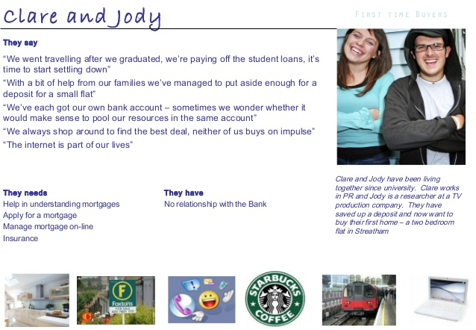
(Source: dancingmango.com)
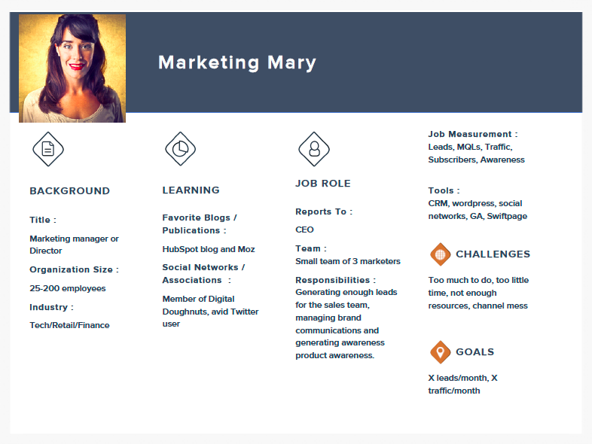
(Source: Hubspot)
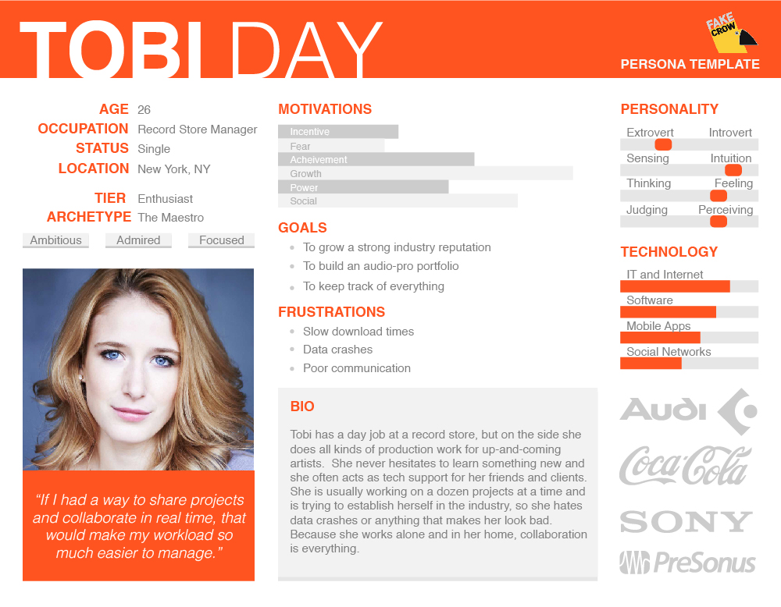
(Source: Xtensio)

keep track of the persona
- Integrate into Web Analytics & CRM:
  - How to Create Custom Audience Segments in Google Analytics - http://blog.hubspot.com/marketing/how-to-create-custom-audience-segments-in-google-analytics-quick-tip
  - Defining Audiences Custom Dimensions in Google Analytics - http://www.lunametrics.com/blog/2015/03/17/defining-audiences-custom-dimensions/
  - How to Create Personas in Hubspot - https://knowledge.hubspot.com/contacts-user-guide-v2/how-to-create-personas
- Continuously create content & marketing around them: 14 Ways to Get More Use Out of Your Buyer Personas - http://blog.hubspot.com/marketing/ways-to-use-buyer-personas
- Make visible - If you want people to adopt the personas, you have to make them visible. Take a little extra time and create graphics that can be displayed around the office for the users. Below is an example from MailChimp:
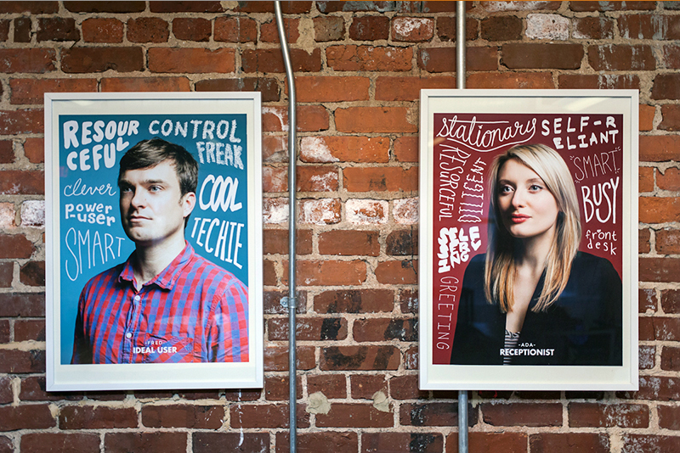
(Source)

Resources & Tips
Here are some tips & resources I used when creating this guide and that can enable you to continue to build and evolve your personas.

Persona Making TIPS
- Personas can, and probably should, change and evolve over time.
- Don't make your persona revolve around your brand, these are whole people.
- Don’t make your personas without flaws.
- Be consistent and make your personas believable.
- Involve key stakeholders, especially people that are client facing.
- Think about how much you need to know about the customer. If you’re “selling” content, you need to know more about your personas than if you’re selling a commodity. Seemingly erroneous information can sometimes be important. For example, preferring Southwest over American Airlines may mean the customer is particularly price conscious.
- Personas are not companies or positions, they’re people. If they have the same pain points, decision criteria & goals, most likely they are the same persona.
- Personas should be distinct from one another.
- As a rule of thumb, you should aim for 3-5 personas, but really you should have enough personas to cover most of your clients/customers (75% or more should fit). Consider putting a sample (or all) of your customers into different persona groups to see if they fit.
- When making personas, consider the user/buyer. Do you have wholesale buyers & end-users? Are both of them involved in the goal you set out to achieve? If so, include them.
- All assumptions should have at least 1 data point to back it up.
- Personas can be created without interviewing customers if you have a lot of data but communicating with your customer is still ideal. Less research = more changes to the personas as you go.

Questions to ask your CustomerS
Consider asking questions to current, past & prospective customers. Here are a few start questions to consider. See the resources section for additional interview questions.
- What is currently keeping you up at night?
- What was your solution/is your current solution to [whatever problems your product solves].
- What was the point where you realized you needed a new solution?
- Ideally after getting a new solution what would your work day look like? How would the work load of your team change?
- How frequently do you seek out information about [your industry]? Where do you find the information you’re looking for?
- How much do reviews from strangers effect your buying decisions? How about from friends?

Questions to Ask Your Employees
It’s a good idea to interview at least 1 person from each customer-facing department (i.e. social media managers, customer service, sales, PR, etc.). Here a few started questions to consider. See the resources section for additional interview questions.
- What trends are you seeing within our company?
- What trends are you seeing within the industry? Would you consider us behind, ahead or in line with these trends?
- Typically when you speak to current or potential customers, what are their biggest problems?
- When you’re making small talk with a customer what do they usually bring up?
- What are some common objections you face from customers?

Questions to Ask Community Members
In order to get to know how peers perceive your company & industry, you may want to reach out to community members. These can be competitors (if you happen to be close with them), people that head boards/associations in your industry, or people that make policy decisions that could effect your company.
- Do you communicate with people outside on our region? How does the landscape look there?
- Who do you consider the big players in the industry? Where would you place [my company]?
- What universities are offering courses/majors that are feeding into our potential employee pool?
- Do you think there are any areas that are lacking attention in our industry?
- Has any marketing piece really caught your eye lately?

Resources

Get in the persona Mindset
- See how Google sees you by logging into your account and checking out your perceived interests are: https://www.google.com/settings/ads
- See your Acxiom cluster with a few quick questions: https://isapps.acxiom.com/personicx/personicx.aspx

Definitions
- Segments - similar entities and fact based breakdown, i.e. lives in Baltimore or doesn't; bought your product or didn't.
- Cohort - similar experiences like elementary school, a generation of people, or people that may have been early adopters like a Kickfunder group--temporary shared attributes, but not likely to every change.
- in-market segment – A segment of people actively looking to buy/consume a product or service.
- Affinity audiences – Interests & overall lifestyle information for a group of people.

Persona Generators
- Xtensio - https://xtensio.com/user-persona
- HubSpot - http://www.makemypersona.com

Getting Stakeholder Buy-In
- Cintell’s 2016 Benchmark Study - http://cintell.net/2016-benchmark

Audience insights
- Google Display Planner - https://adwords.google.com/da/DisplayPlanner/Home (must be logged into Google AdWords)
- Twitter Audience Insights (must be logged into Twitter ads)
- Facebook Audience Insights - https://business.facebook.com/ads/manager/audiences/manage (must be logged into Facebook ads)

Consumer Segmentation Tools
- Acxiom’s “What’s My Cluster?” - https://isapps.acxiom.com/personicx/personicx.aspx
- Acxiom’s “The 39 Demographic Segments Comprising Facebook Audience Insights” - http://www.antoniocalero.com/2015/08/12/audience-insights-segments
- Acxiom’s Life Style Clustering System: “PersonicX” - http://c.ymcdn.com/sites/dema.site-ym.com/resource/resmgr/Member_Resources/Lifestage_Clustering.pdf
- Nielsen PRIZM Premiere - https://segmentationsolutions.nielsen.com/mybestsegments/Default.jsp?ID=30&menuOption=segmentdetails&id1=CLA.PZP&prevSegID=CLA.PNE&filterstate=&sortby=segment_code
- Experian’s Mosaic - http://www.experian.com/marketing-services/mosaicportal.html
- Experian’s Mosaic (PDF) - https://www.experian.com/assets/marketing-services/product-sheets/mosaic-usa.pdf

Spy On your Competitions
- FollowerWonk - https://moz.com/followerwonk/analyze
- SpyFu - https://www.spyfu.com/overview
- Moat - https://moat.com
- SimilarWeb - https://www.similarweb.com
- iSpionage - https://www.ispionage.com
- Owler - https://www.owler.com
- Kissmetrics “25 Sneaky Online Tools” - https://blog.kissmetrics.com/25-sneaky-online-tools
- Kissmetrics “37 Best Marketing Tools to Spy on Your Competitors” - https://blog.kissmetrics.com/james-bond-of-the-web

Additional Interview Questions
- 20 Questions to Ask When Creating Buyer Personas - http://blog.hubspot.com/blog/tabid/6307/bid/30907/9-Questions-You-Need-to-Ask-When-Developing-Buyer-Personas.aspx
- 22 Questions to Ask When Creating Buyer Personas - https://www.sensiblemarketing.com/blog/bid/156636/22-Questions-to-Ask-When-Creating-Buyer-Personas
- How to Create Detailed Buyer Personas for Your Business - http://blog.hubspot.com/blog/tabid/6307/bid/33491/Everything-Marketers-Need-to-Research-Create-Detailed-Buyer-Personas-Template.aspx
- Step by Step Guide to Creating a Marketing Persona - https://www.conversioner.com/blog/step-step-guide-creating-marketing-persona

Public Research data
Consider backing up your personas with publically available data, this will allow you to potential see if you have personas that are unlikely to exist or help you supplement spotty or nonexistent internal data.
- “Data, Data, Data: Thousands of Public Data Sources” from BigML.com - https://blog.bigml.com/2013/02/28/data-data-data-thousands-of-public-data-sources/
- Google’s BigQuery Public Datasets - https://cloud.google.com/bigquery/public-data/
- “Free Public Data Sets” from Springboard.com - https://www.springboard.com/blog/free-public-data-sets-data-science-project/

Free Stock Photography
You’ve got to get your persona photos from somewhere. If you don’t have the budget/time to take your own. Here are a few resources:
- Unsplash - http://unsplash.com
- Gratisography - http://gratisography.com/
- Flickr’s Creative Commons Photos - https://www.flickr.com/creativecommons/
- Splitshire - http://www.splitshire.com/
- 550+ Royalty-Free Stock Photographs from Hubspot - http://blog.hubspot.com/marketing/75-free-stock-photos-im-ht
- Bonus: Vince Vaughn Free Stock Business Photographs from the movie “Unfinished Business” - http://mashable.com/2015/03/04/vince-vaughn-stock-photos

More persona Info & my sources
- Persona Examples - http://academy.hubspot.com/examples
- Mailchimp’s User Persona Research - https://blog.mailchimp.com/new-mailchimp-user-persona-research/
- Cintell’s Intelligent Guide to Buyer Personas - http://cintell.net/intelligent-guide-to-buyer-personas
- Personas: The Art and Science of Understanding the Person Behind the Visit - https://moz.com/blog/personas-understanding-the-person-behind-the-visit
- Marketing Personas: The Complete Beginner’s Guide - https://blog.bufferapp.com/marketing-personas-beginners-guide
- Amazing Resources for Creating Buyer Personas - http://writtent.com/blog/resources-for-creating-buyer-personas-using-the-right-content
- Improve your Targeting and Tell a Story By Creating Buyer Personas - http://blog.marketo.com/2012/12/improve-your-targeting-and-tell-a-story-by-creating-buying-personas.html
- 10 Step Persona Building Guide for More Effective Marketing - https://www.imforza.com/blog/persona-building-guide
- How To Create Customer Personas With Actual, Real Life Data - http://conversionxl.com/creating-customer-personas-using-data-driven-research
- How to Build Better Buyer Personas to Drive Killer Content - http://blog.hubspot.com/blog/tabid/6307/bid/31043/How-to-Build-Better-Buyer-Personas-to-Drive-Killer-Content.aspx
- DIY User Persona (User Experience) - http://www.ux-lady.com/diy-user-personas/
- Customer Journey Maps & Buyer Personas: The Modern Tool Kit for Marketing - http://www.silverpop.com/Documents/Whitepapers/2015/Customer-Journey-Maps-WP-2015-Silverpop.pdf
- How to Create Detailed Buyer Personas for Your Business - http://blog.hubspot.com/blog/tabid/6307/bid/33491/Everything-Marketers-Need-to-Research-Create-Detailed-Buyer-Personas-Template.aspx
- All About Developing Buyer Personas - https://www.sensiblemarketing.com/blog/all-about-developing-buyer-personas-part-5

